MunimJi — Features & Build Checklist
Nov 4, 2026 · @Harsh Gupta

Overview
MunimJi lets shop owners send bill photos or PDFs into a Telegram group, where AI agents read and GST-check them, and a CA approves everything before filing.
Item | Detail
Hackathon | Flip the Switch (WeMakeDevs x DevTools Academy x Switch)
Track | Track 1: Best Business Workflow
Deadline | Nov 7, 2026, 11:59 PM IST (aim to submit by evening)
Core rule | AI reads, code checks, human decides
Data | All bills, shops and GST numbers are synthetic

Architecture
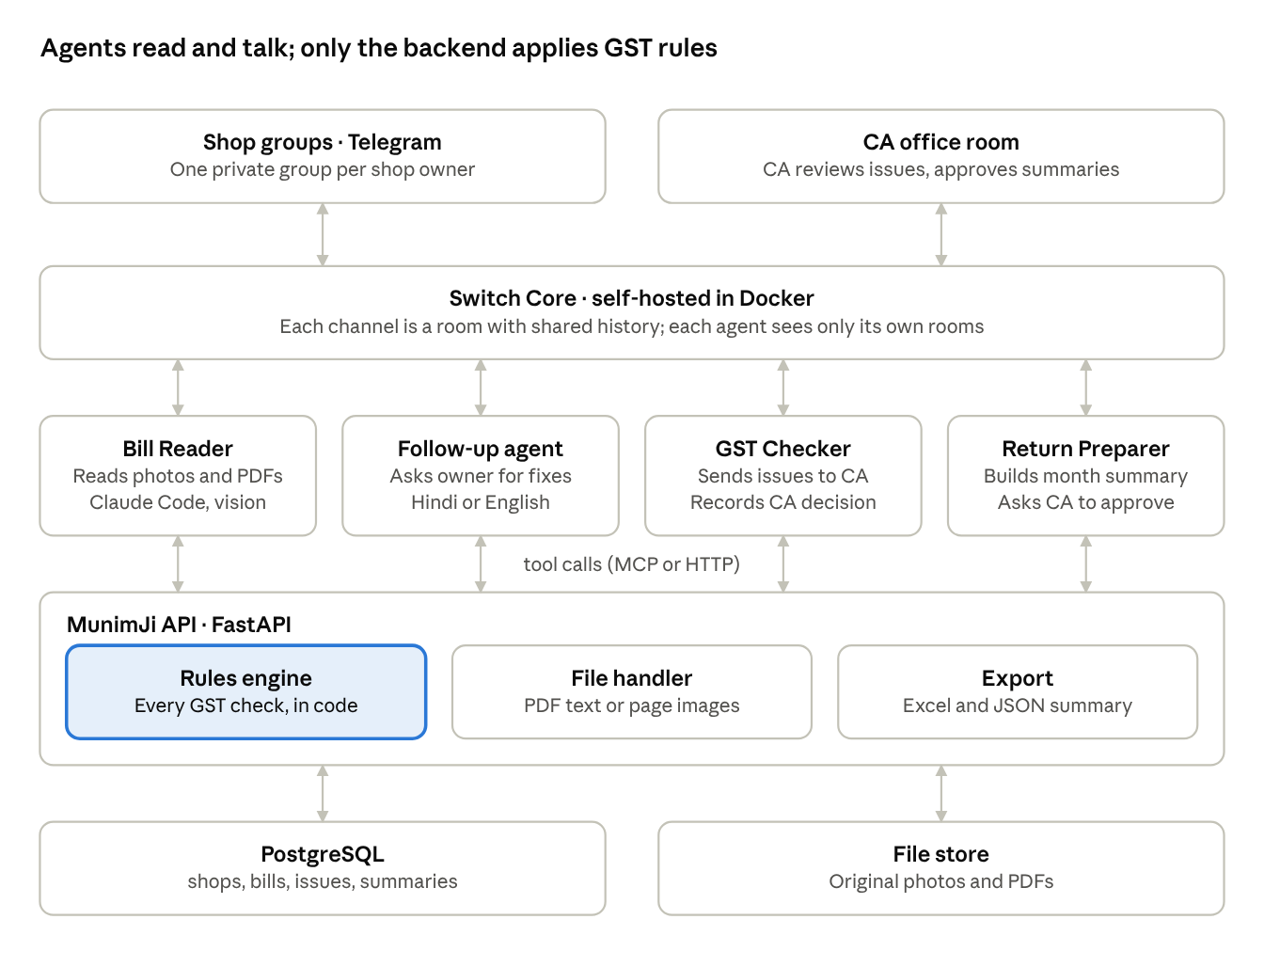
MunimJi architecture · chat, Switch, agents, backend, storage
People stay in their chat apps; Switch carries messages to the agents, and the agents call the backend, which alone applies GST rules and stores data.

Components
Four layers: chat apps where people work, Switch connecting them, agents doing the reading and talking, and a FastAPI backend that owns data and every GST rule.
Component | Layer | What it does | Tech
Shop groups (one per shop) | Chat | Owner uploads bills, confirms details, gets follow-ups | Telegram (Mattermost fallback)
CA office room | Chat | CA reviews issues, approves summaries | Mattermost or Telegram
Switch Core | Switch | Turns each channel into a room; keeps history, rules, tasks, decisions; controls which agent sees which room | Switch, self-hosted in Docker
Switch Console | Switch | Runs agents locally and connects chat apps | Desktop app
Agent template | Switch | Creates all agents and rooms in one step | Switch template YAML
Bill Reader | Agent | Reads photos and PDFs, extracts fields, asks owner to confirm | Claude Code (vision)
Follow-up agent | Agent | Explains simple problems to the owner in Hindi or English | Claude Code
GST Checker | Agent | Posts serious issues to the CA room and records the CA's decision | Custom agent via Switch protocol (LangGraph) or Claude Code
Return Preparer | Agent | Builds the month-end summary and asks the CA to approve | Custom agent via Switch protocol or Claude Code
MunimJi API | Backend | Saves bills, runs checks, routes issues, builds summaries | FastAPI
Rules engine | Backend | GSTIN format and check digit, tax-type by state code, totals, required fields, duplicates | Python, unit-tested
File handler | Backend | Text extraction from text PDFs; converts scanned PDF pages to images | pypdf / pdf2image
Database | Storage | shops, bills, issues, summaries | PostgreSQL
File store | Storage | Original photos and PDFs | Local folder (S3 later)
Export | Backend | Month-end summary as Excel and JSON | openpyxl
Agents call the backend through tools (an MCP server or plain HTTP). Agents never compute tax themselves; they call the rules engine and report its result.

Workflow
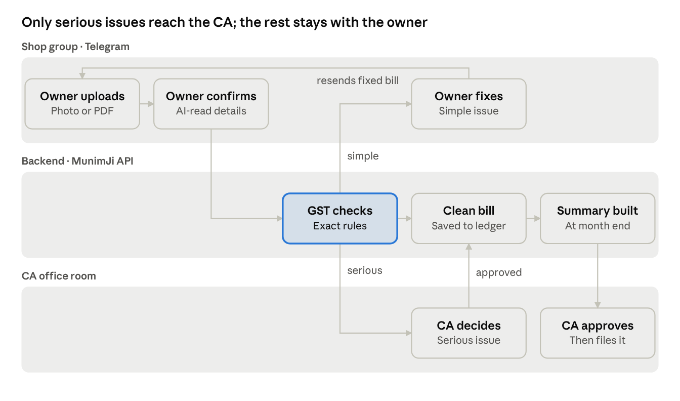
bill workflow · 3 rooms, 8 steps
Every bill is checked by code on arrival; simple problems loop back to the owner, serious ones wait for the CA, and nothing is filed until the CA approves the month-end summary.

Implementation phases
Six phases, each ending in something you can demo; phases 1-4 are the minimum winning build, 5-6 are polish.

Phase 0: Foundation (Nov 4)
Goal: one agent answering in one room, and the repo ready.
- Switch Console + Docker running; Claude Code replying in Mattermost
- One Telegram group connected through Switch
- Repo layout: api/ (FastAPI), rules/, agents/ (instructions + template YAML), seed/ (synthetic bills), docker-compose.yml
- PostgreSQL in docker-compose; tables shops, bills, issues, summaries
- Synthetic data: 15-20 bills (photos + PDFs), fake GSTINs with valid check digits
Done when: tagging the agent in Telegram gets a reply, and docker compose up starts the API and database.

Phase 1: Bill intake and reading (Nov 5 morning)
Goal: a photo or PDF becomes a confirmed bill record.
- File handler: detect type; text PDF → extract text; scanned PDF or photo → image pages
- Bill Reader instructions: extract fields as strict JSON, never invent a missing value
- API POST /bills stores the file + extracted fields with status pending_confirm
- Owner confirms or corrects in the thread; PATCH /bills/{id} sets confirmed
Done when: 5 sample bills (3 photos, 2 PDFs) are saved correctly after owner confirmation.

Phase 2: Rules engine (Nov 5 afternoon)
Goal: every confirmed bill is checked by code.
- GSTIN present; 15-character format; check digit
- Tax type: same state code as the shop → CGST + SGST; different → IGST
- Totals: line items + tax = bill total (small rounding tolerance)
- Required fields: date, bill number, HSN, supplier name
- Duplicate: same supplier GSTIN + bill number
- Each failure → an issues row with type, severity (simple or serious) and rupees at risk
- Unit tests for every rule against the synthetic set
Done when: all tests pass and each synthetic bad bill produces exactly the expected issue.

Phase 3: Routing across rooms (Nov 6 morning)
Goal: the right person hears about each problem.
- Simple issues → Follow-up agent posts in the shop group; a resent bill re-enters Phase 1
- Serious issues → GST Checker posts in the CA room with options: approve, reject, ask supplier
- CA reply → POST /issues/{id}/decision; issue closed and bill status updated
- Confirm room isolation: shop agents see only their own group
Done when: one simple and one serious issue each reach the right room and close after a reply.

Phase 4: Month-end summary (Nov 6 afternoon)
Goal: the CA gets a reviewable monthly summary.
- GET /summaries/{shop}/{month}: clean bills, open issues, totals, tax credit available
- Return Preparer posts the summary in the CA room and asks for approval
- On approval, export Excel + JSON; the CA downloads and files herself
Done when: the CA approves a summary and opens the exported file.

Phase 5: Reproducibility and polish (Nov 6 evening)
- Switch template YAML creates every agent and room
- make demo (or one script): start services, load seed data, apply the template
- Hindi / Hinglish replies; blurry-photo request
- Full dry run of the demo script on a clean clone

Phase 6: Submit (Nov 7)
- Record the video; finish the README with both diagrams above
- Submit by evening; then blog and #HowISwitch post if time allows

Features
Build the must-haves first; they alone make a complete, judgeable demo.

Must-have
Feature | What it does | Who uses it | Where
Private shop groups | One Telegram group per shop; shops never see each other's bills | Shop owner | Shop group
Bill photo / PDF intake | Owner drops a bill photo or PDF (incl. multi-page or e-invoice PDFs); agent acknowledges within seconds | Shop owner | Shop group
Bill Reader agent | Reads text PDFs directly and photos or scanned PDFs as images; extracts supplier, GSTIN, date, bill number, items, amount, tax | AI | Shop group
Confirm or correct | Owner approves the extracted details or types a fix | Shop owner | Shop group
GST checks (code) | GSTIN present and valid format + check digit; CGST/SGST vs IGST by state code; totals add up; duplicate bill; missing fields | System | Backend
Issue routing | Simple problems go back to the owner; serious ones go to the CA | AI + system | Both rooms
Follow-up agent | Polite reminder to the owner with the rupee amount at risk | AI | Shop group
CA office room | One place to see problems across all shops and approve or reject | CA | CA room
Approve / reject / ask supplier | CA decides on serious issues with one reply | CA | CA room
Month-end summary | Return Preparer totals clean bills, open issues and tax credit | AI | CA room
Summary file export | Excel or JSON file the CA reviews and uploads herself | CA | CA room
One-command setup | Template + seed data so judges can reproduce the demo | Judges | Repo

Nice-to-have
Feature | What it does | Who uses it
Hindi / Hinglish replies | Agents reply in the language the owner writes in | Shop owner
Blurry photo detection | Agent asks for a clearer photo instead of guessing | Shop owner
Deadline reminders | "5 days left; last month you sent ~70 bills, you've sent 64" | Shop owner
Per-shop status command | Owner types a command to see bills sent, clean and pending | Shop owner
CA dashboard command | One command lists every shop's status for the month | CA

Stretch (only if time is left)
Feature | What it does
Voice notes | Owner speaks in Hindi; agent transcribes and links it to the bill
Supplier chase | Agent drafts a message to the supplier for a corrected bill, sent only after owner approval
Trust levels | Agent earns the right to auto-accept clean bills from repeat suppliers after enough CA approvals
Second shop in demo | Shows privacy between shops and the CA handling many clients

Build checklist
One day per layer: setup today, bill pipeline tomorrow, routing and summary on Nov 6, polish and submit on Nov 7.

Nov 4 (today): setup
- ☐ Register for the hackathon on WeMakeDevs
- ☐ Install Docker and Switch Console; check your OS build works (Windows/Linux are early access)
- ☐ Run the 10-minute quickstart; get Claude Code replying in a Mattermost room
- ☐ Connect one Telegram group (test early; fall back to Mattermost if it fails)
- ☐ Connect Claude Code to the Switch docs MCP and read the agent protocol
- ☐ Confirm an agent only sees the rooms it is added to
- ☐ Create the repo with a README skeleton
- ☐ Make 15-20 synthetic bills as photos and PDFs, including one multi-page PDF (clean, missing GSTIN, wrong tax type, wrong total, duplicate, blurry)
- ☐ Generate fake GSTINs with a correct format and check digit
- ☐ Optional: claim a Track 3 issue labelled hackathon

Nov 5: bill pipeline
- ☐ Postgres tables: shops, bills, issues
- ☐ FastAPI service the agents call to save and check bills
- ☐ Bill Reader agent: photo or PDF in (extract text from text PDFs, convert scanned PDF pages to images), structured details out, posted back for confirmation
- ☐ Owner confirm / correct flow
- ☐ GST checks in code: GSTIN present, format, check digit
- ☐ GST checks in code: CGST+SGST vs IGST from state codes
- ☐ GST checks in code: totals, required fields, duplicate detection
- ☐ Unit tests for every check against the synthetic bills

Nov 6: routing, CA room, summary
- ☐ Create the CA office room with the CA, GST Checker and Return Preparer
- ☐ Route simple issues to the shop group via the Follow-up agent
- ☐ Route serious issues to the CA room with approve / reject / ask supplier
- ☐ Record the CA's decision on the bill and close the issue
- ☐ Return Preparer month-end summary message
- ☐ Export the summary as Excel or JSON
- ☐ Hindi / Hinglish replies (nice-to-have)
- ☐ Switch template YAML that creates all agents and rooms
- ☐ Seed script that loads shops and synthetic bills
- ☐ Full end-to-end dry run of the demo script

Nov 7: polish and submit
- ☐ Fix bugs found in the dry run
- ☐ Fresh-machine test: clone, one command, demo works
- ☐ Record the 3-minute demo video
- ☐ Finish the README (see submission checklist)
- ☐ Submit by evening, well before 11:59 PM IST
- ☐ Optional: blog post, #HowISwitch post, Wispr scorecard

Submission checklist
The repo, README and video are what judges see; each judging criterion should be answerable from them in under a minute.

What to submit
- ☐ Public GitHub repo
- ☐ README: problem, demo GIF, architecture diagram (shop groups, Switch, agents, CA room)
- ☐ README: a section titled "How Switch is used" naming the rooms, agents and the protocol
- ☐ README: one-command setup and the seed data
- ☐ README: "All data is synthetic" and "AI prepares, CA files"
- ☐ Demo video, about 3 minutes
- ☐ Submission form filled on WeMakeDevs

Judging self-check
Criterion | Question judges ask | How MunimJi answers it
Use of Switch | Would it stop working without Switch? | Private Telegram rooms per shop, a shared CA room, agents carrying issues between them
Technical execution | Can someone clone and run it? | Template YAML + seed script + tested rule-based checks
Creativity and impact | Fresh idea, real problem? | Monthly GST bill chaos for Indian small shops and their CAs
Presentation | Do the video and README show Switch clearly? | Video follows one bill from photo to CA approval; README diagram

Demo video beats
- The problem: a bill pile and a CA chasing shop owners
- Owner sends a bill photo, then a PDF invoice; agent reads both; owner confirms
- Bill with no GSTIN; Follow-up agent flags the rupee amount at risk
- Wrong tax type goes to the CA room; CA chooses "ask supplier"
- Duplicate bill caught
- Month-end summary; CA approves and downloads the file
- Architecture slide and "AI prepares, CA decides"

Cut list if behind schedule
If you are behind on the evening of Nov 6, cut in this order and keep the core loop: photo, checks, CA approval, summary.
- Voice notes and supplier chase (stretch)
- Deadline reminders and status commands
- Hindi replies (mention as planned in the README)
- Telegram: run the whole demo on Mattermost and note Telegram as supported
- Excel export: show the summary message and export JSON only
Never cut: the GST checks in code, the CA approval step, one-command setup, or the demo video.

